**Create external view**

Note: External view ZMT_CV can be seen in se11

1) ABAP Perspective

2) Right click on package Z001- new-other - **Dictionary view**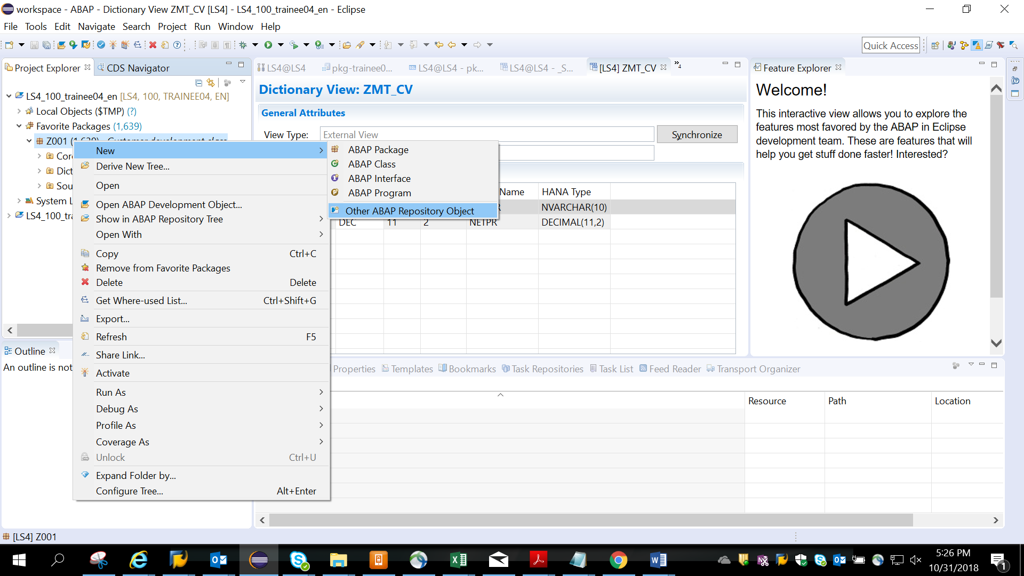

3)Search for Dictionary view

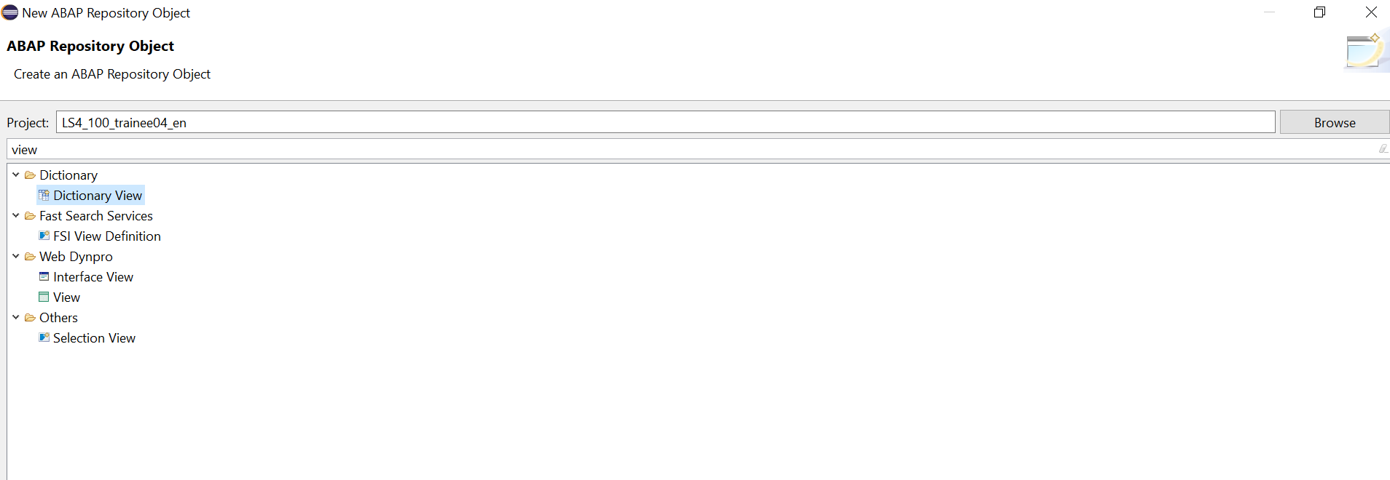

3) choose external radio button

Dictionary View Name: **ZMT_MV**

Hana View: **MT_CV**

Note: Dictionary View name must begin with Z.

Give the HANA calculation view MT_CV created in earlier demos t

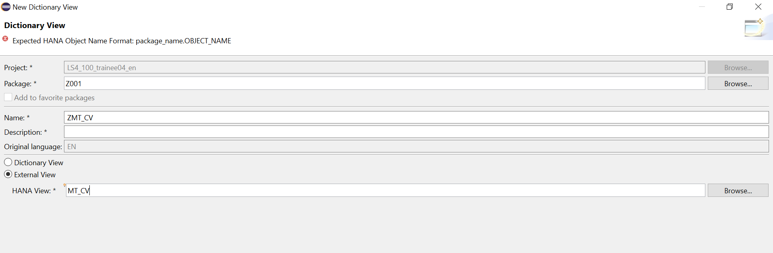

4)Click on browse, the Hana View with package is populated

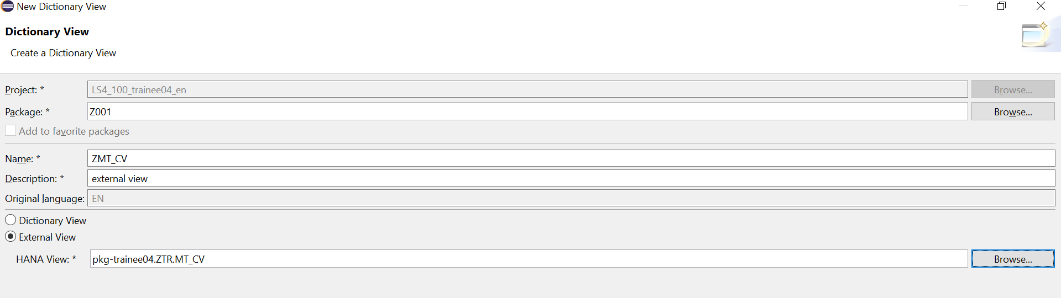5)choose any package and Finish

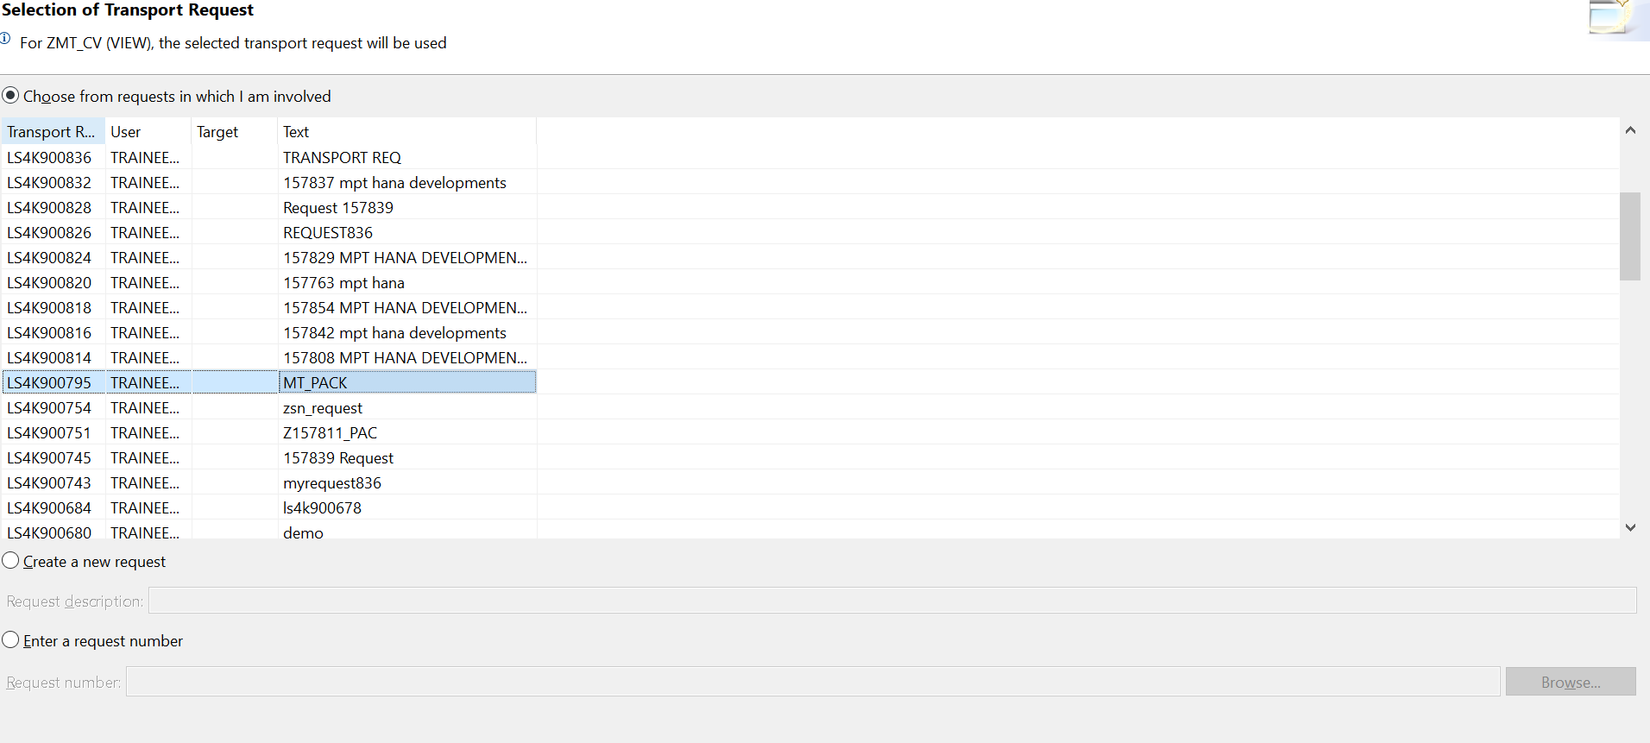

6)Synchronize and

7) activate- Run as ABAP Application

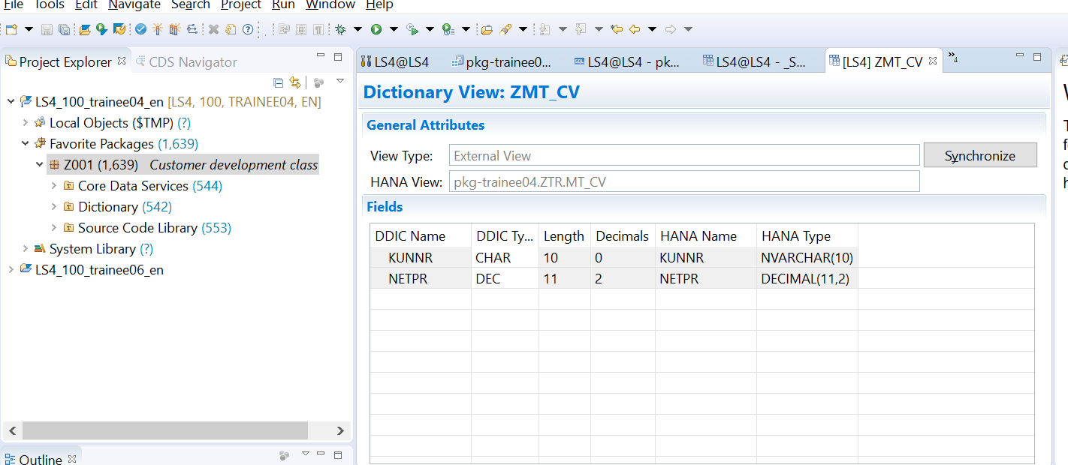

7)Check the view in SE11

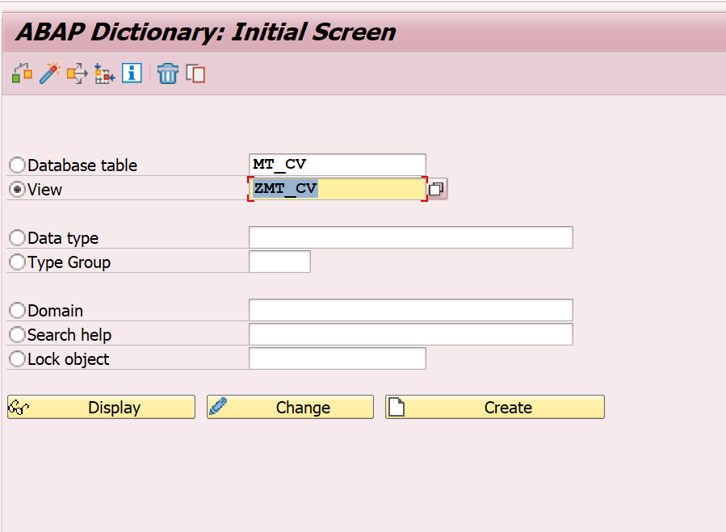

8) 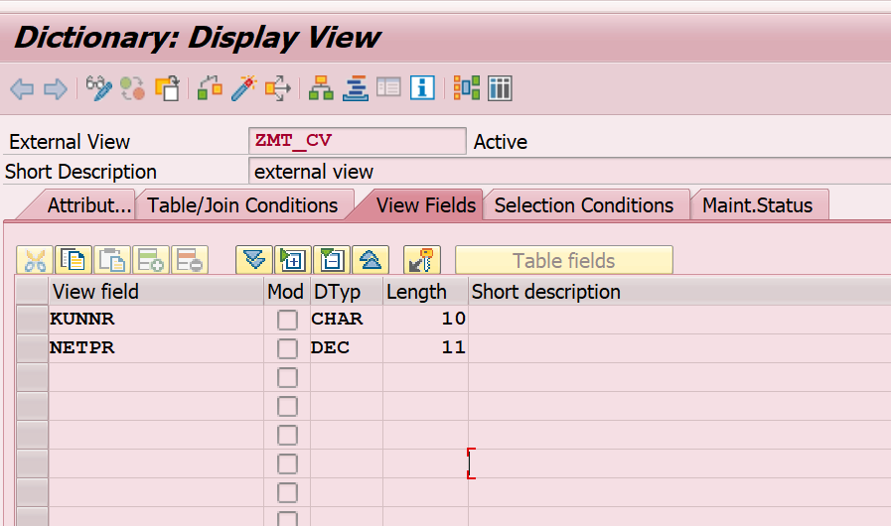

9) Create se38 program with below code

REPORT Z.  
  
DATA IT_SALES TYPE TABLE OF ZMT_CV.  
  
SELECT * FROM ZMT_CV INTO TABLE IT_SALES.  
  
CL_DEMO_OUTPUT=>DISPLAY( IT_SALES ).

10)Save and activate.